BRIEF CV
FRANCESCO FERRARA, MD

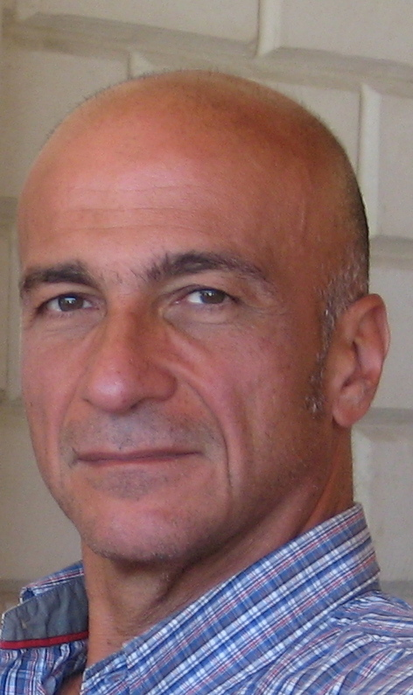

Birth:  Education:  Accademic Training:  Professional  Activities:  Honors:  Books:  Pubblications:  Congress organizations: | 28th of June,1954, Acerra - Na, Italy  1978 MD University of Naples  1983 Specialty, in CardioVascular Surgery University of Naples, Italy  1989 Specialty, in General Surgery University of Naples, Italy  1981– present Cardiac Surgeon Monaldi Hospital Naples Italy  1979- present Private Practice as Phlebologist (sclerotherapy)  Studio Flebologico Ferrara Acerra – Na v Kuliscioff 25 frferr@tiscali.it  International Correspondent of French Society of Phlebology  International Correspondent of French Society of Angiology  Member of the Editorial Board of the Journal "Phlebologie"  F. Ferrara: Terapia sclerosante ed elastocompressiva delle flebopatie  Piccin 2009 Padua – Italy  Sclerotherapy with Sigg's method in F. Mariani: Scleroterapia  Minerva Medica 2006 Turin - Italy  The most important of the 200 publications have been:  - The compression in sclerotherapy of the 1500 sapheno-femoral junction: our experience XVI World Meeting UIP Monte-Carlo, June 30th, 2009  - Sclerotherapy: my method Angéiologie, 2010, Vol. 62, N°3 p. 82-86  Journées Franco-italiennes de Phlébologie: Editions of 2006, 2007, 2008, 2009 and 2010

